

The Daily Star

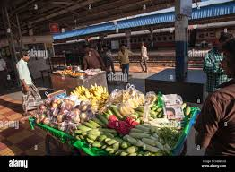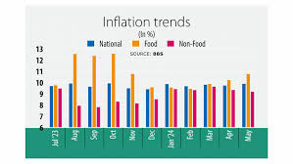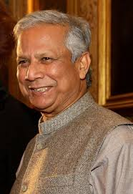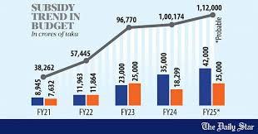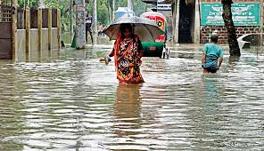DHAKA TUESDAY JUNE 4, 2024

Reasons behind the increasing subsidy allocation in the upcoming budget is the high energy prices in the international market and elevated capacity payments.

He said the government has **See page 2 col 4**

Before fiscal year 2021-2022, the subsidy allocation for the power sector were between TK 7,000 crore to TK 8,000 crore

Khondokar Golam Moazzem, research director at the Centre for Policy Dialogue, said the main

The subsides and incentive expenditures in the upcoming budget are going to be more than that of the current fiscal year.

The subsides have mainly been increasing in the power, energy ,and the agriculture sectors.

Even though the government plans to increase power price four to five times a year, the highest subsidy allocation is likely to go towards the power sector.

Finance ministry officials said the increased subsidy allocation was largely due to the arrears in the power and agriculture sectors.

**Mexico elects Sheibaum as first woman president**

**Break the syndicates, not the dreams of migrants**

**An elderly woman wades through knee-deep water in Taratan area of Sylhet city’s Shahjalal neighbourhood yesterday afternoon. Due to the Overflowing of rivers, overnight rains and mountain torrents many areas in the city have gone water, affecting at least 15,000 families**.

Custodial Death

Victim’s family leaves home fearing reprisal

**Says neighbour; police from body**

**STAR REPORT**

The family of woman, who died in Jashore police custody on Sunday morning, locked their house and moved to a relatives home after the incident, said neighbour.

Afroza Begum, 40, died hours after being picked up by e. **See Page 2 Col 1**

Benazir’s abuse of power a cause for grave concern

**Says TIB, demands action against those who aided, protected the former IGP**

**STAFF CORRESPONDENT**

Transparency International Bangladesh yesterday expressed grave concerns over accumulation of substantial illegal over wealth by a former police and Rab chief.

In a statement,it said the misuse of power by those who are in top positions **See Page 6 col 5**

**rain whizzes past fruit sellers who love placed themselves right on the lines near the airport railway station, putting not only themselves but also their customers at risk. Multiple trains frequently pass through the station, opposite the Hazrat Shahjalal International Airport in the capital**.

**MD ASADUZZAMAN**

**Inflation, fueled by higher food prices, climbed 15 basis points to 9.89 percent in May from 9.74 percent a month earlier, figures from Bangladesh bureau of statistics showed yesterday.**

**This is the highest rise on their See Page 2 Col 1**

Inflation hits seven-month high

Higher food prices largely to blame

Labour migration expert prof CR Abrar said those responsible for creating an un certain situation for the aspirant migrants need to be identified first and then punished.

He said many of these workers have left their occupations to get a job in Malaysia, while many others have sold their assets to arrange migration costs.

**See Page 2 Col 1**

**Grameen Bank counsel Sharpens barbs against Prof Yunus**

Yunus’ lawyer bins ‘false claims’

**STAF CORRESPONDENT**

Grameen Banks Chief Legal Adviser Masud Akhter yesterday said Nobel Laureate Dr Muhammad Yunus deceived 1.05 crore members of Grameen Bank and misappropriated their money, a claim Yunus’s lawyer vehemently denied.

“He is talking about curses. He has deceived 1.05 crore members of Grameen Bank. He has used and misappropriated their money for personal gains. Their curse has fallen upon him,” he told newsman at a press briefing on the Supreme court premises.

**See page 2 Col 4**

**Jamil Mahmud**

Despite getting emigration clearance, around 17,000 aspirant migrant workers could not fly to Malaysia before the May 31 deadline due to alleged mismanagement in the recruitment process.

Many had to travel to Dhaka from other districts for different purposes, including pre-migration medical tests.

Fate of 17,000 workers up in the air

Despite clearance they were unable to go to Malaysia by May 31 Deadline

**RAJAUL KARIM BYRON and ASIFUR RAHMAN**

Power, agriculture to drive up subsidies

**England begin T20 world cup defence today**

REGD.No.DA 781 Vot.XXXIV No. 135 JASHITA 21,1431 BS [www.thedailystar.net](http://www.thedailystar.net) ZIIQAd 26, 1445 HIJRI 16 PAGES PLUS LIFE STYLE : TK 15.00